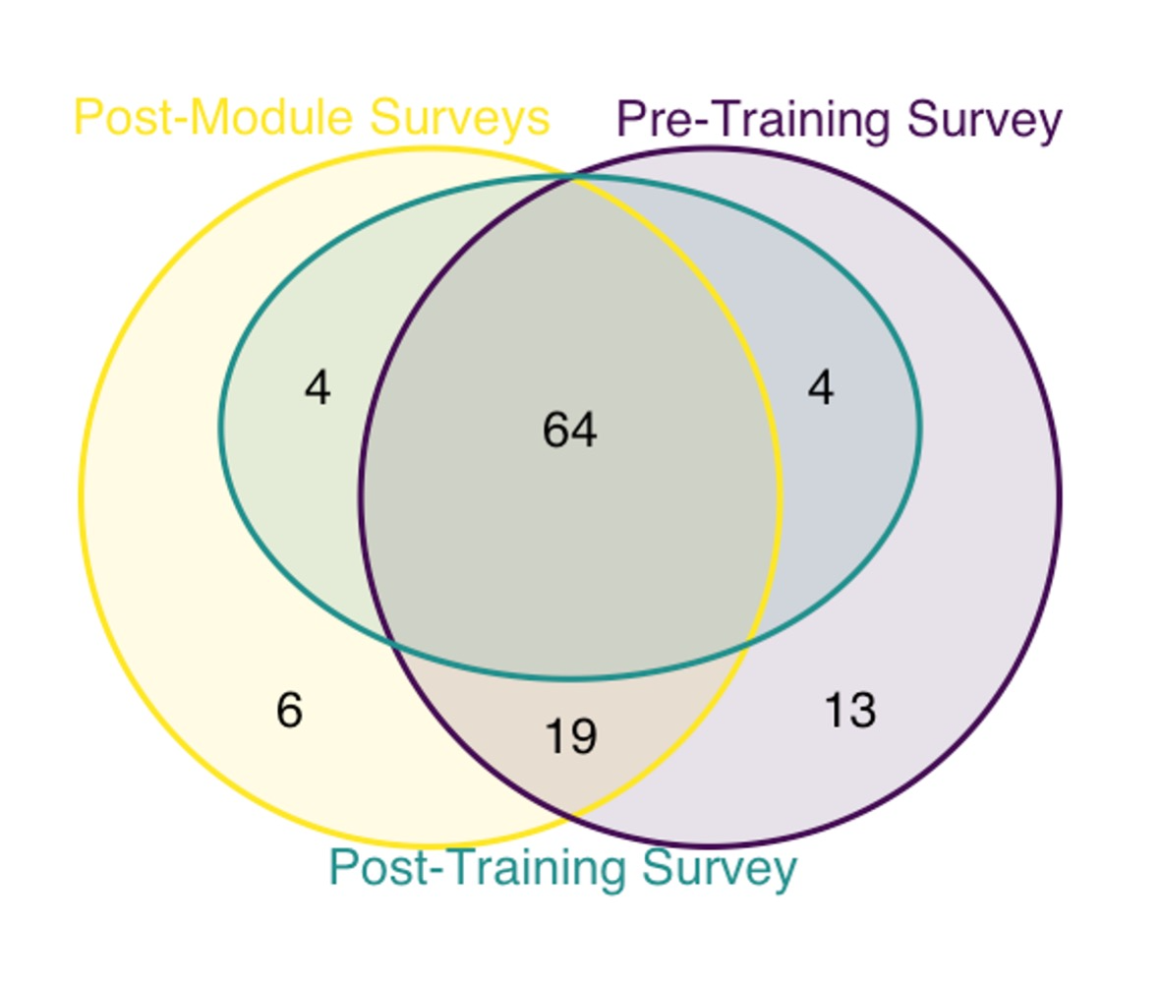

**Figure S1. Participant survey completion.** The Venn diagram shows the number of participants who completed the pre-training survey, post-training survey, and at least one of the four post-module surveys. Of the 110 participants who submitted at least one survey, 93 completed at least one post-module survey, and 68 completed both the pre- and post-training surveys.

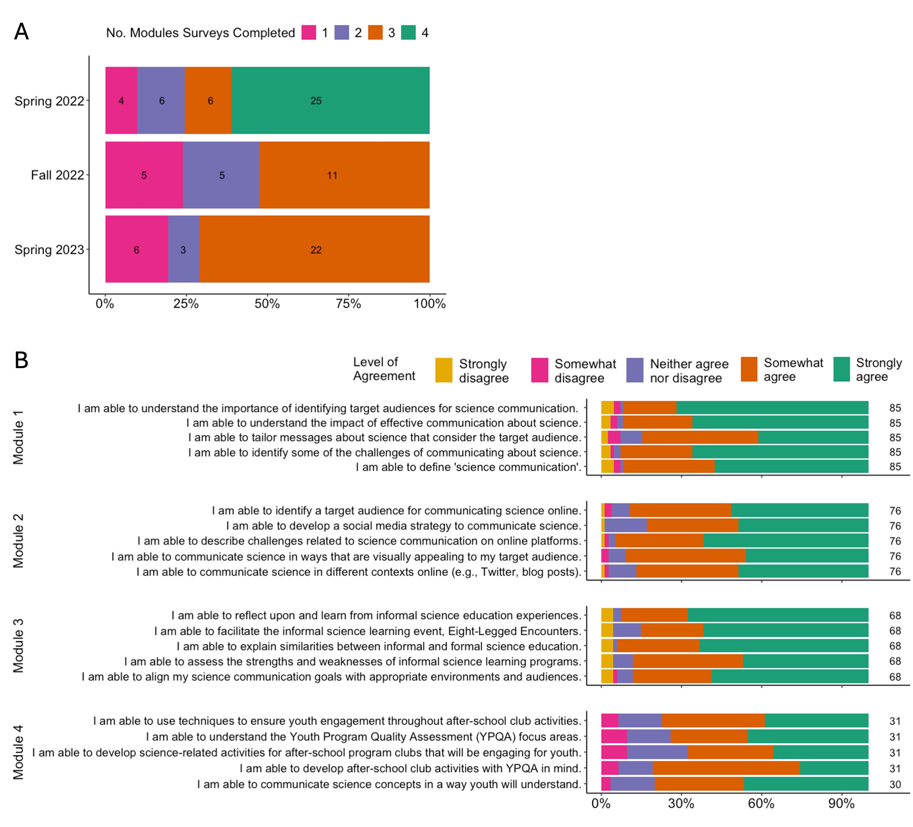

**Figure S2. Participation and responses to post-module surveys.** (A) The number of post-module surveys submitted by participants across training sessions (Spring 2022, Fall 2022, and Spring 2023). Module 4 was removed after the first session. In each session, at least 50% of participants completed all available post-module surveys. (B) Module effectiveness was evaluated by participants’ level of agreement with statements. Bars show the proportion of responses at each agreement level, aggregated across statements within each module. The numbers at the end of each bar indicate the number of participant responses represented. Participants broadly agreed that the modules met the objectives.

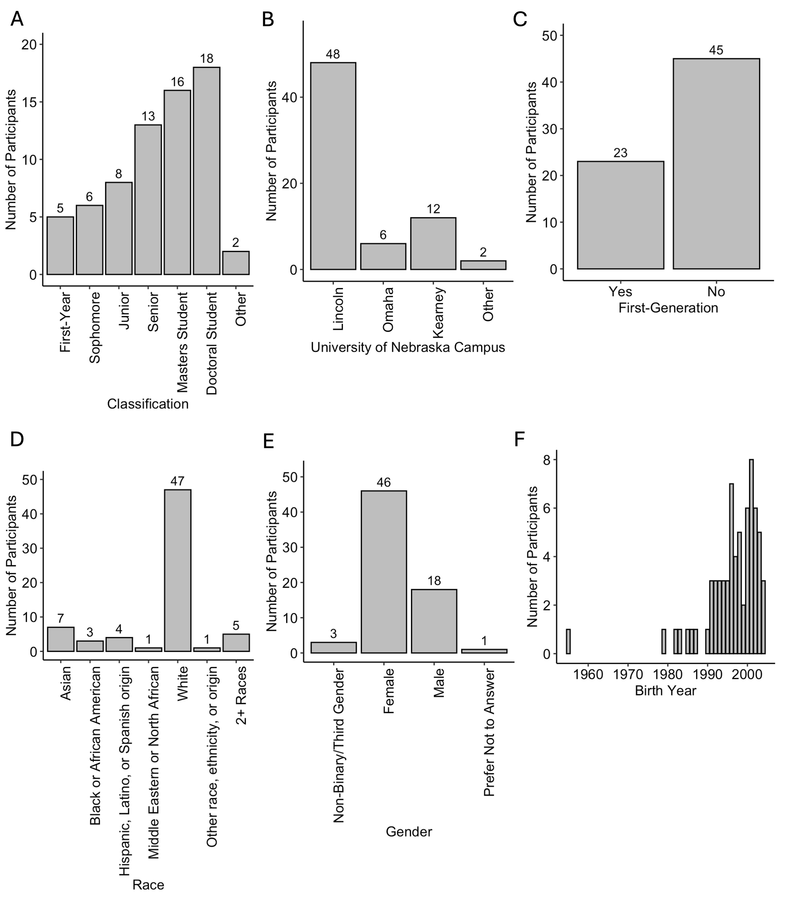

**Figure S3. Demographics of participants.** Graphs represent the demographic information of the 68 participants that completed the pre- and post-training surveys: (A) College Classification, (B) Affiliation, (C) First-Generation, (D) Race, (E) Gender, and (F) Birth Year. The bars show the number of responses to each option.

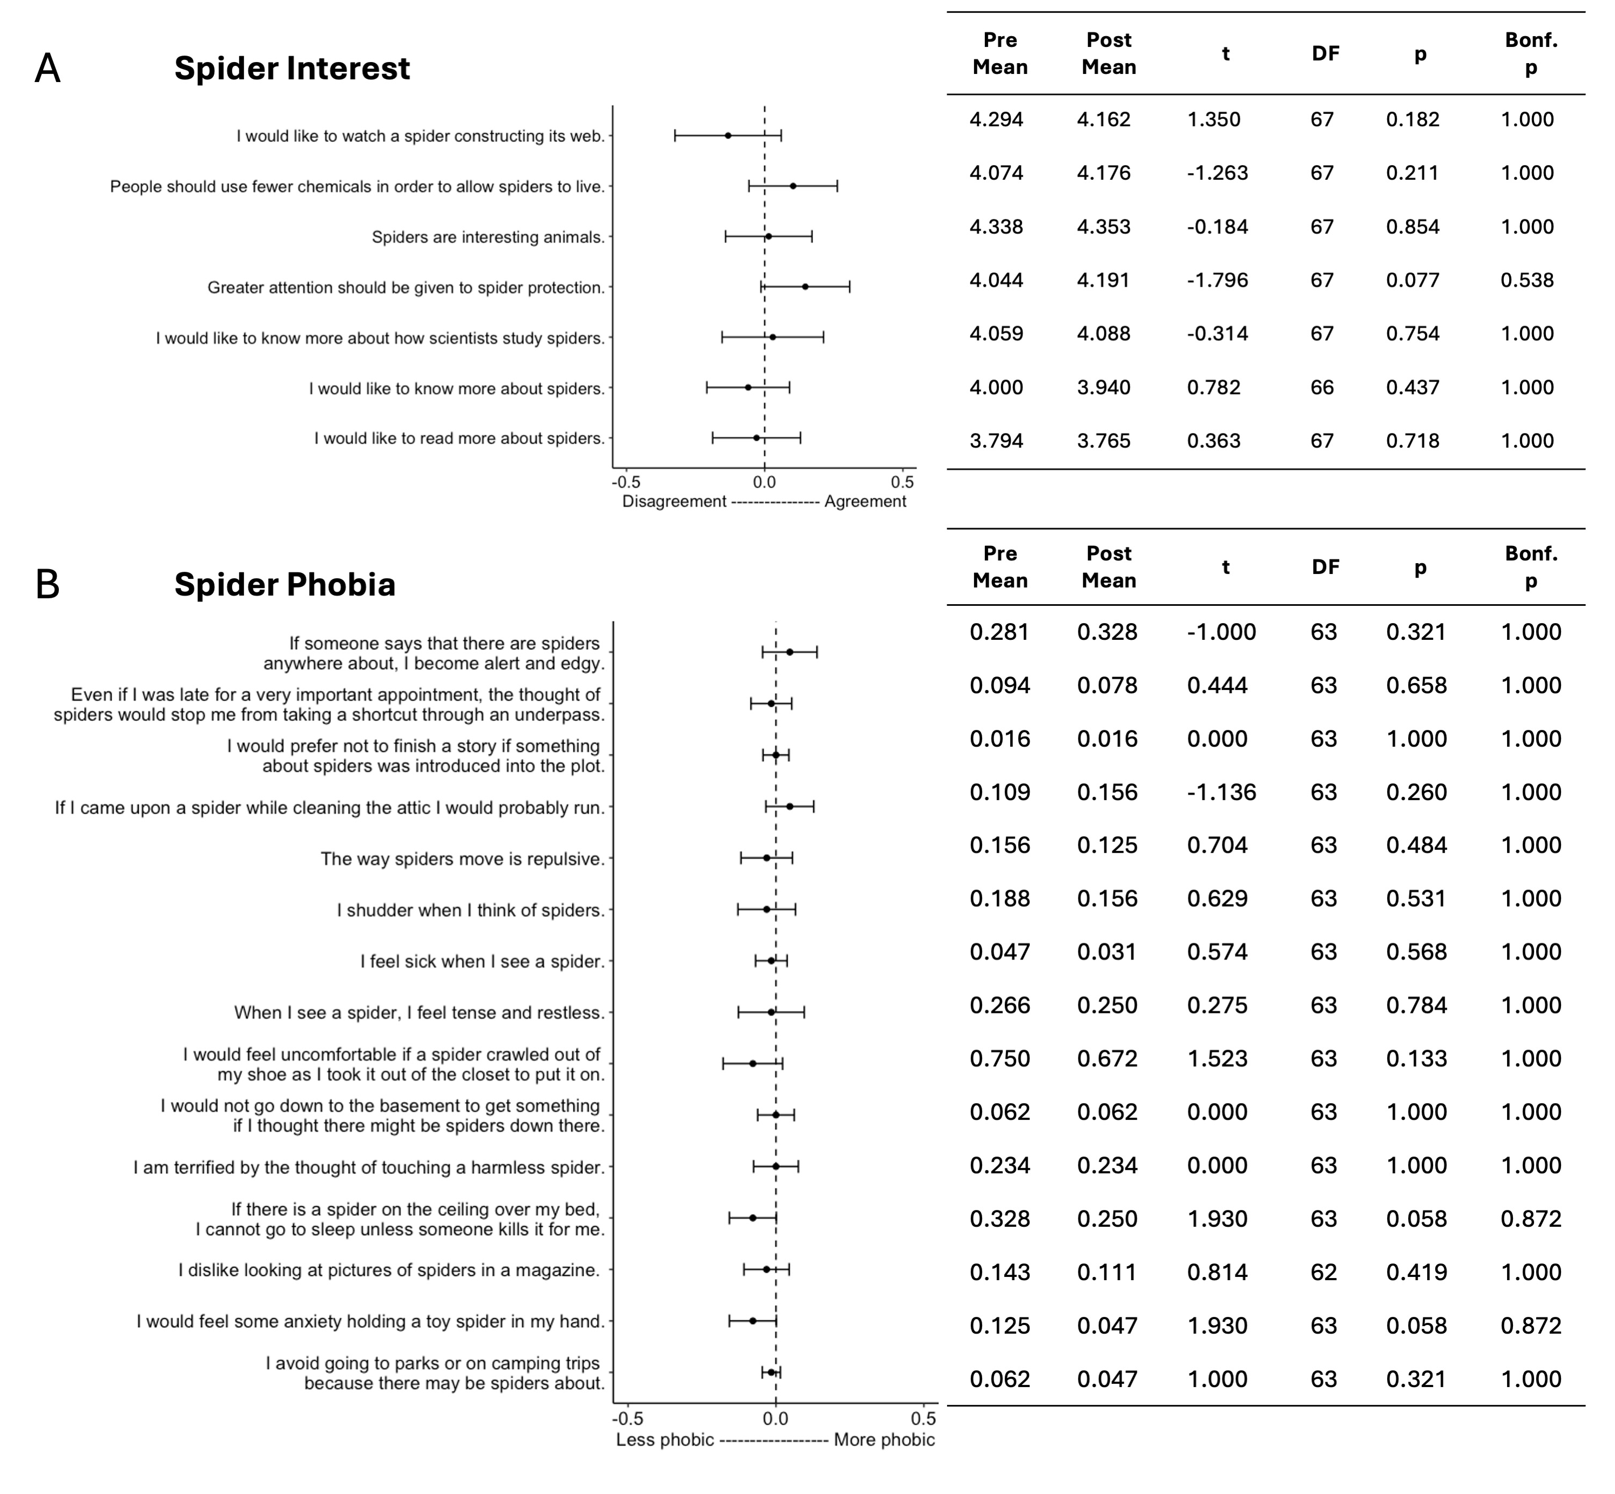

**Figure S4. Shifts in responses to spider-related statements.** Results of paired t-tests comparing pre- to post-training responses for individual statements related to (A) spider interest (1 = strongly disagree to 5 = strongly agree) and (B) spider phobia (0 = false, 1 = true). Points and error bars represent means and 95% CI, respectively. A significant change would be reflected by error bars not overlapping with the dashed line at zero (the null hypothesis of no change). Final p-values are Bonferroni-corrected based on the number of statements within each theme. No single spider-related statement showed a significant shift after the training.

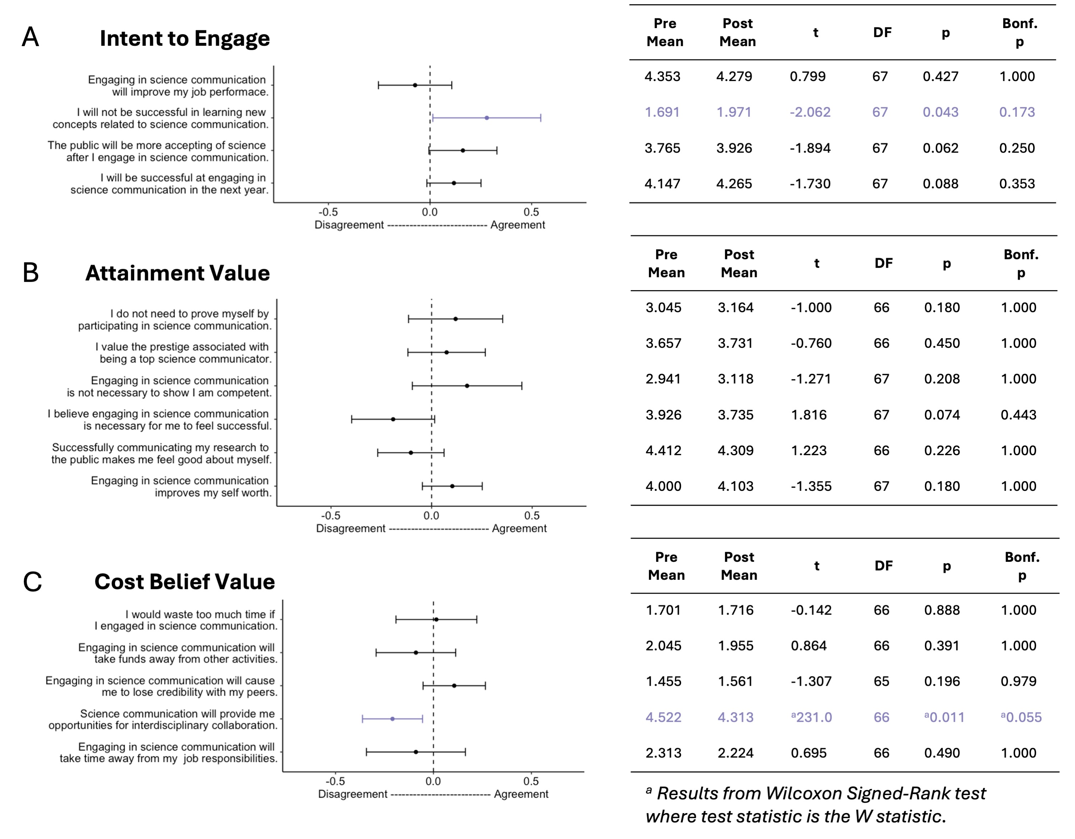

**Figure S5. Shifts in responses to science communciation-related statements.** Results of paired t-tests comparing pre- to post-training responses for individual statements (1 = strongly disagree to 5 = strongly agree) related to (A) intention to engage in science communication (B) attainment value of science communication, and (C) cost belief value of science communication. Points and error bars represent means and 95% CI, respectively. A significant change would be reflected by error bars not overlapping with the dashed line at zero (the null hypothesis of no change). Final p-values are Bonferroni-corrected based on the number of statements within each theme. Purple indicates statements with significant p-values before Bonferroni correction. No single science communication-related statement showed a significant shift after the training.

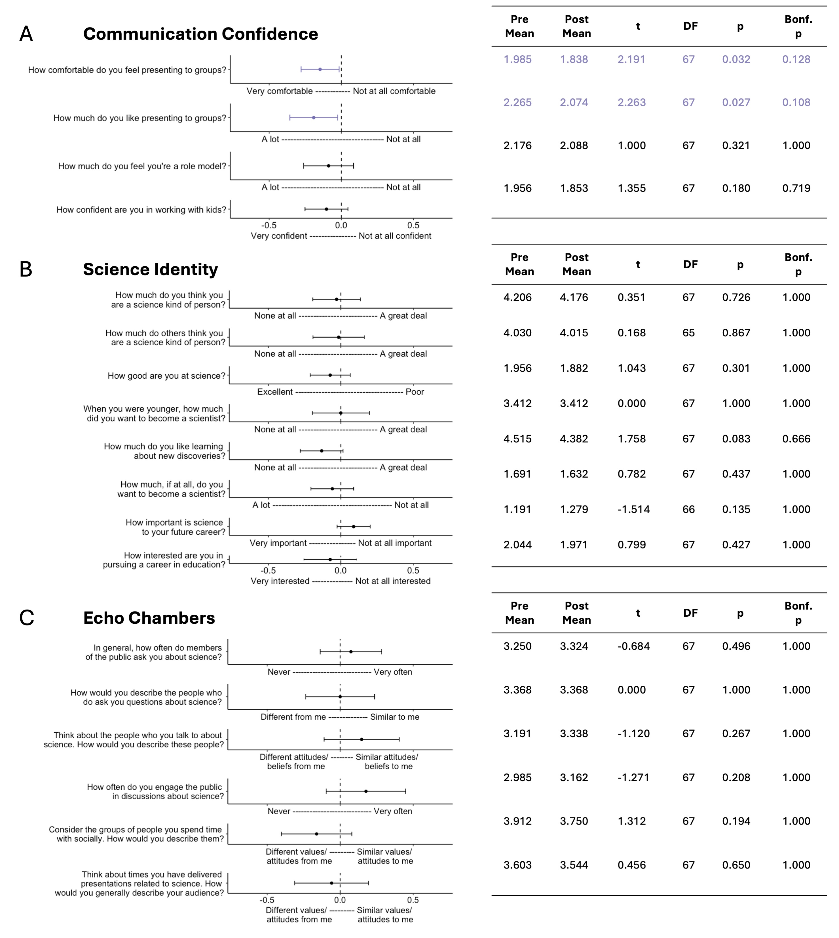

**Figure S6. Shifts in responses to communication-, science-, and audience-related statements.** Results of paired t-tests comparing pre- to post-training responses for individual statements related to (A) communication confidence (scaled 1-4) (B) science identity (‘none at all’ = 1 to ‘a great deal’ = 5 and others scaled 1-4), and (C) echo chambers (scaled 1-5). Points and error bars represent means and 95% CI, respectively. A significant change would be reflected by error bars not overlapping with the dashed line at zero (the null hypothesis of no change). Purple indicates statements with significant p-values before Bonferroni correction. Final p-values are Bonferroni-corrected based on the number of statements within each theme. No single statement showed a significant shift after the training.

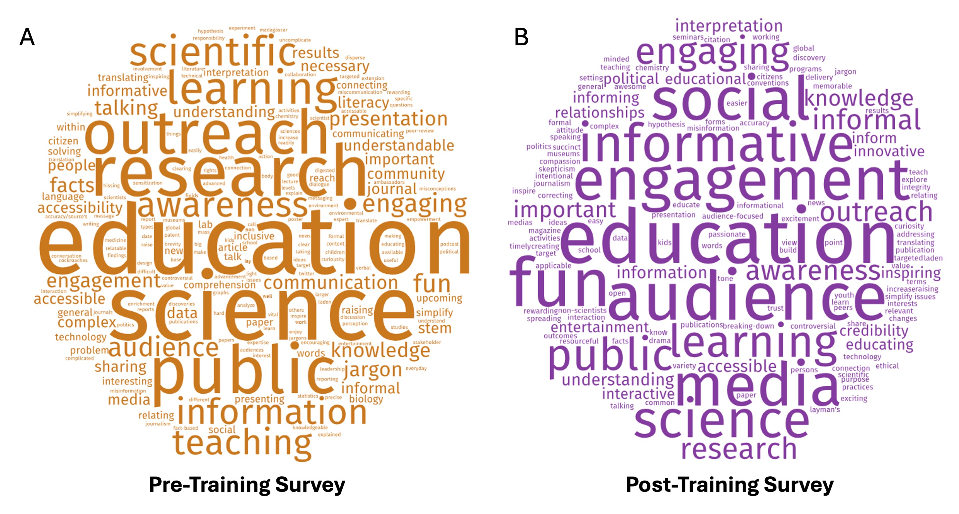

**Figure S7. Participant-entered descriptions of science communication**. Participants entered three words or phrases describing science communication in both (A) pre- and (B) post-training surveys. Responses were visualized using wordclouds.com, where word size reflects the frequency of use. While ‘education’ and ‘science’ remained common across time points, responses shifted from terms like ‘science’, ‘public’, ‘outreach’, and ‘research’ pre-training to ‘audience’, ‘fun’, ‘social media’, and ‘engagement’ post-training.